Project Design Phase-II Technology Stack (Architecture & Stack)

|  |  |
| --- | --- |
| **Date** | **05 November 2022** |
| **Team ID** | **PNT2022TMID08477** |
| **Project Name** | **Project -Real time river water quality monitoring and control system** |
| **Maximum Marks** | **4 Marks** |

# Technical Architecture:

The Deliverable shall include the architectural diagram as below and the information as per the table1 & table 2

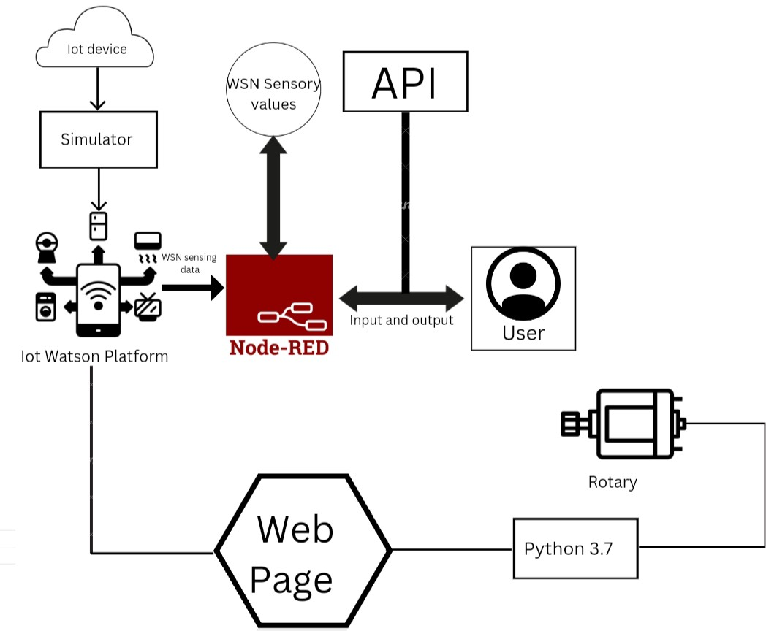

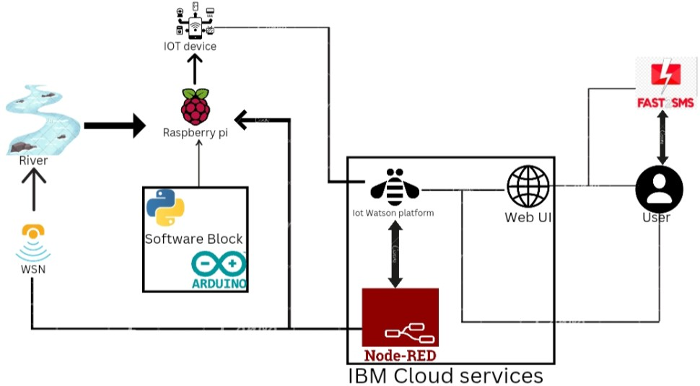

# Table-1 : Components & Technologies:

|  |  |  |  |
| --- | --- | --- | --- |
| S.No | Component | Description | Technology |
| **1.** | **User Interface** | **How user interacts with application e.g.**  **Web UI, Mobile App, Chatbot etc.** | **HTML, CSS, JavaScript / Angular Js / React Js etc.** |
| **2.** | **Application Logic-1** | **Logic for a process in the application** | **Java / Python** |
| **3.** | **Application Logic-2** | **Logic for a process in the application** | **IBM Watson STT service** |
| **4.** | **Application Logic-3** | **Logic for a process in the application** | **IBM Watson Assistant** |
| **5.** | **Database** | **Data Type, Configurations etc.** | **MySQL, NoSQL, etc.** |
| **6.** | **Cloud Database** | **Database Service on Cloud** | **IBM DB2, IBM Cloudant etc.** |
| **7.** | **File Storage** | **File storage requirements** | **IBM Block Storage or Other Storage**  **Service or Local Filesystem** |
| **8.** | **External API-1** | **Purpose of External API used in the application** | **IBM Weather API, etc.** |
| **9.** | **External API-2** | **Purpose of External API used in the application** | **Aadhar API, etc.** |
| **10.** | **Machine Learning Model** | **Purpose of Machine Learning Model** | **Object Recognition Model, etc.** |
| **11.** | **Infrastructure (Server / Cloud)** | **Application Deployment on Local System / Cloud**  **Local Server Configuration: Cloud Server Configuration :** | **Local, Cloud Foundry, Kubernetes, etc.** |

Table-2: Application Characteristics:

|  |  |  |  |
| --- | --- | --- | --- |
| S.No | Characteristics | Description | Technology |
| **1.** | **Open-Source Frameworks** | **List the open-source frameworks used** | **Technology of Opensource framework** |
| **2.** | **Security Implementations** | **List all the security / access controls implemented, use of firewalls etc.** | **e.g. SHA-256, Encryptions, IAM Controls, OWASP etc.** |
| **3.** | **Scalable Architecture** | **Justify the scalability of architecture (3 – tier,**  **Micro-services)** | **Technology used** |
| **4.** | **Availability** | **Justify the availability of application (e.g. use of load balancers, distributed servers etc.)** | **Technology used** |
| **5.** | **Performance** | **Design consideration for the performance of the application (number of requests per sec, use of Cache, use of CDN’s) etc.** | **Technology used** |